# Deep L-layer neural network

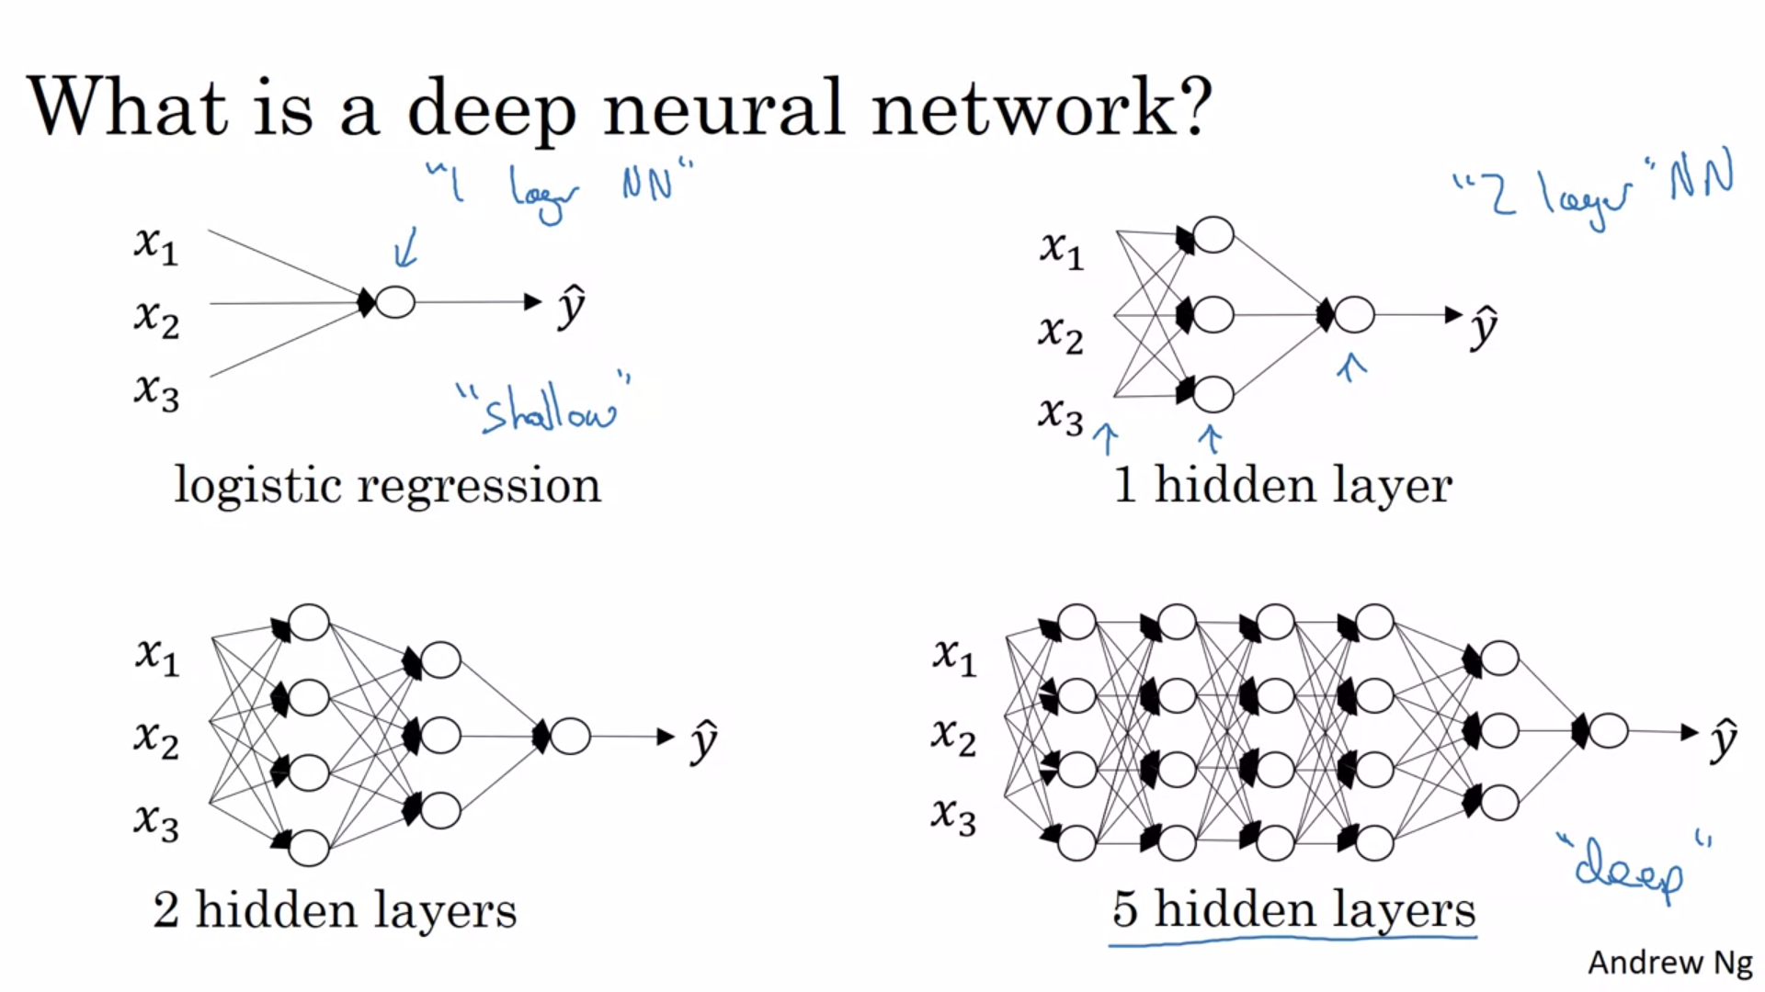

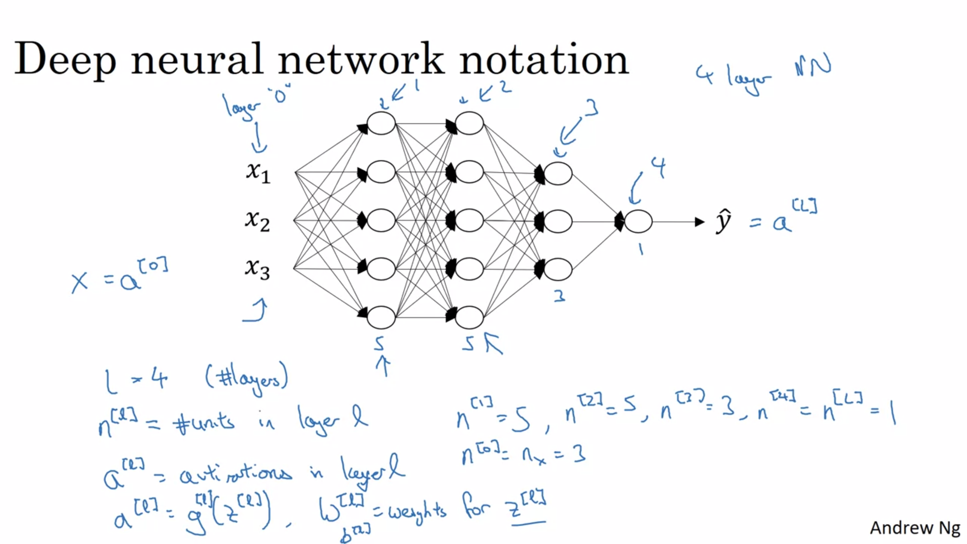

# Forward Propagation in a Deep Network

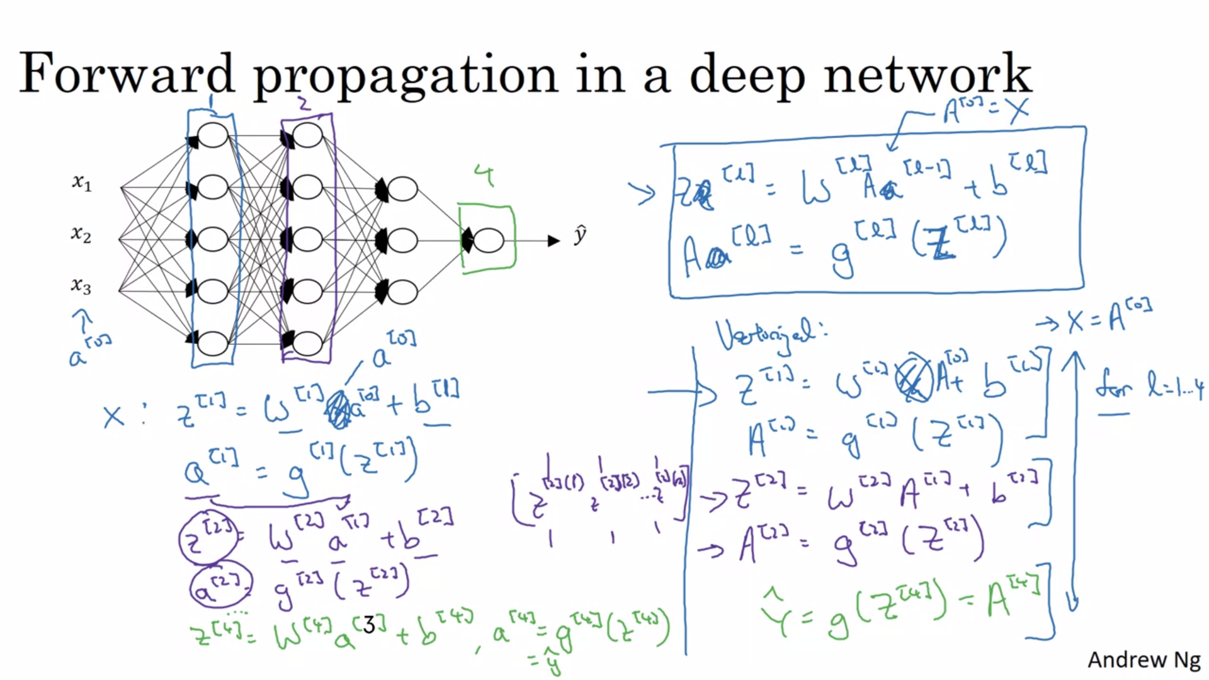

We can see for calculating activations in different layers, we need a for loop here which in this case is OK since there is no other way to calculate forward propagation without for loop.

# Getting your matrix dimensions right

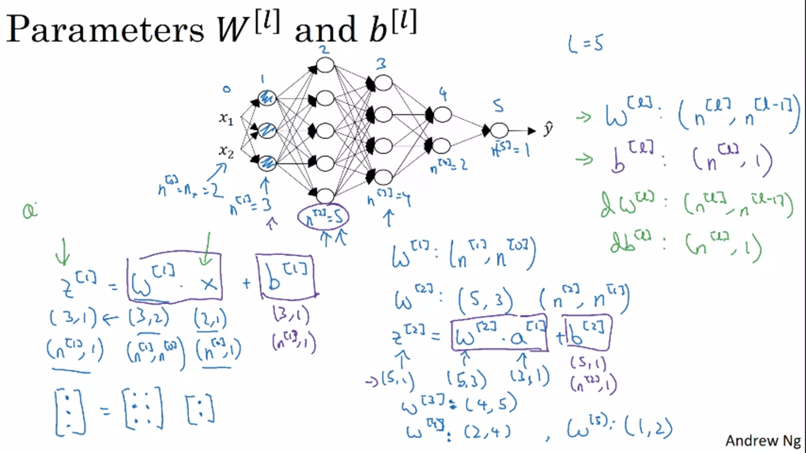

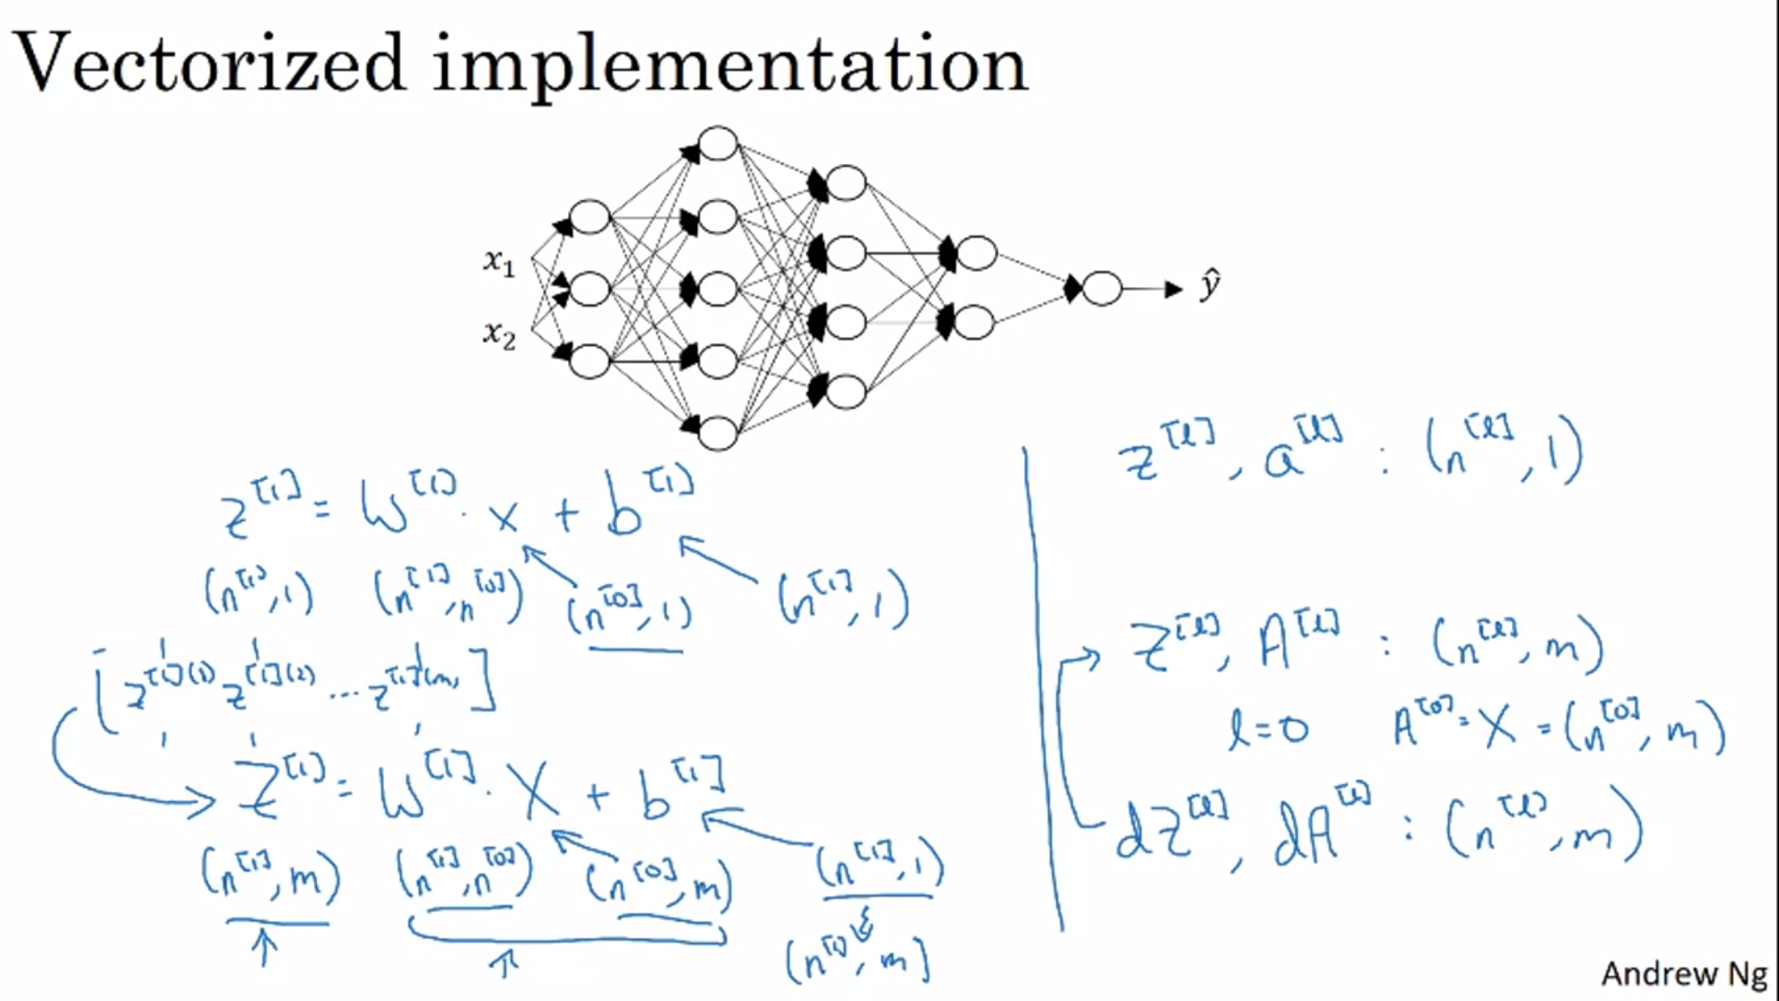

The dimensions of W1.X are (n[1],m) and the dimensions of b1 are (n[1],1). But they are added together due to concept of python broadcasting where on running python automatically changes dimension of b1 from (n[1],1) to (n[1],m).

# Why deep representations?

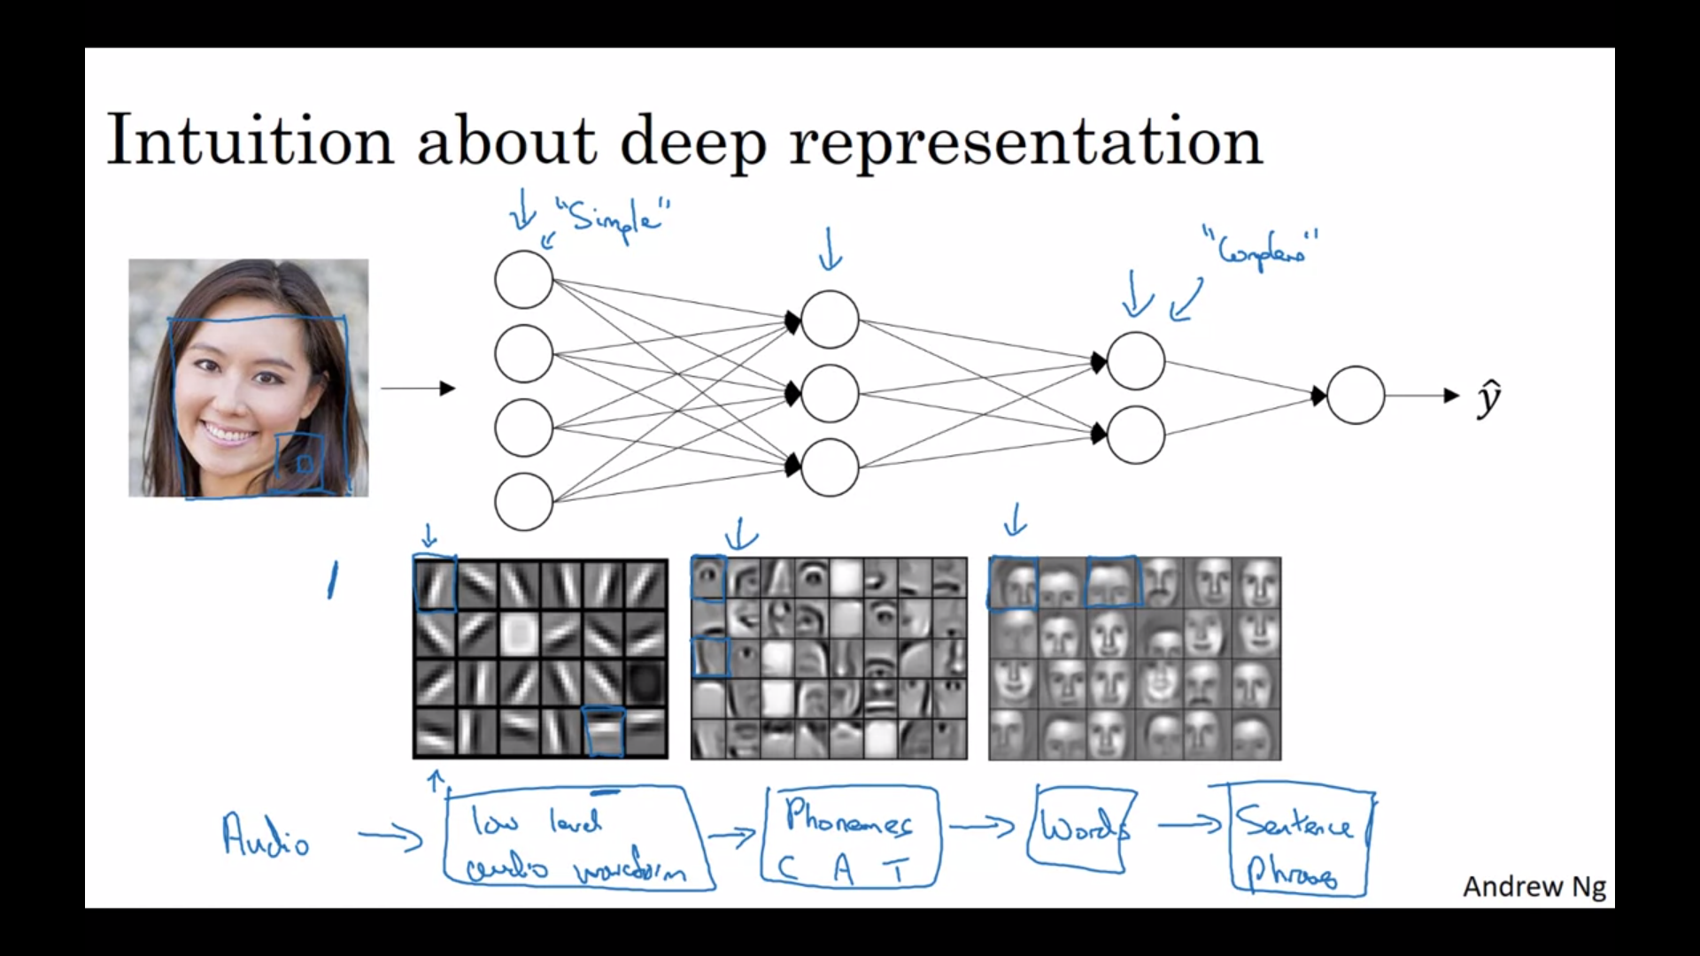

Here each small square represents a single neuron in hidden layers

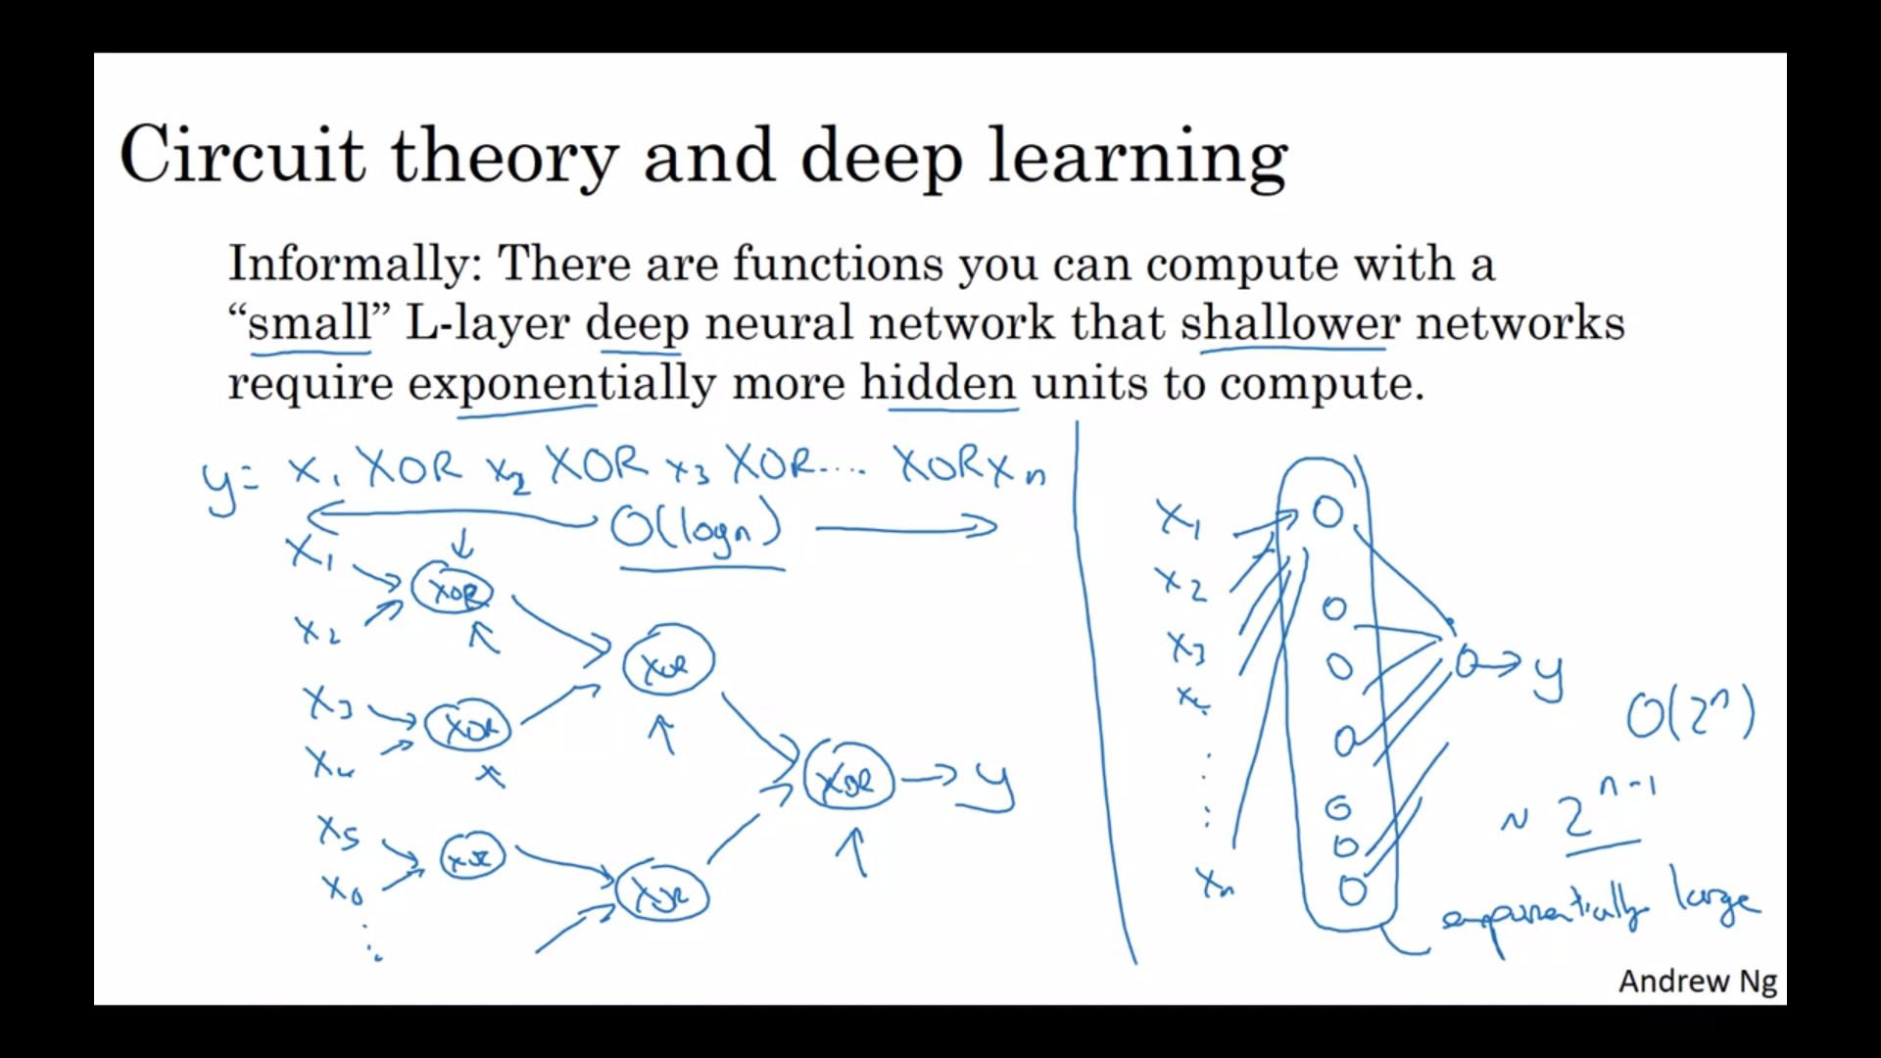

# Building blocks of deep neural networks

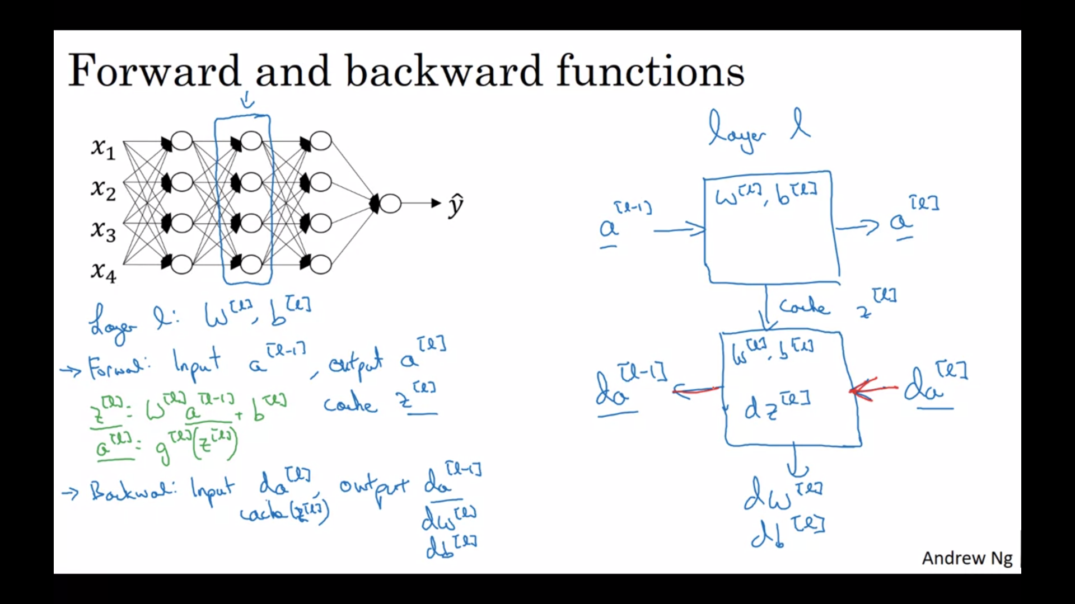

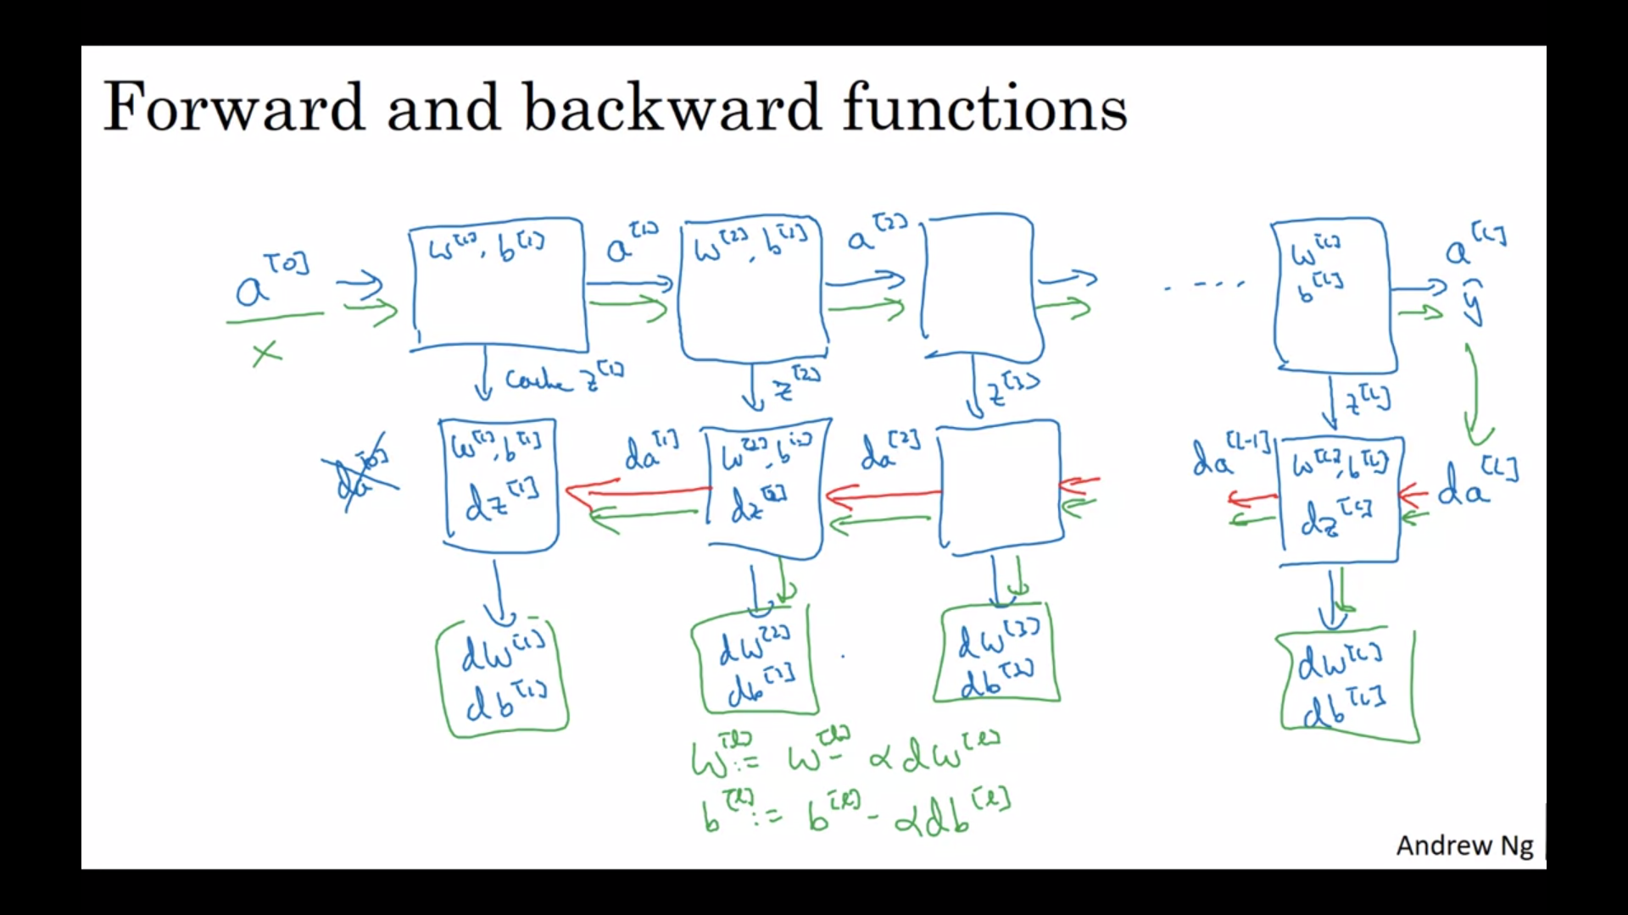

# Forward and Backward Propagation

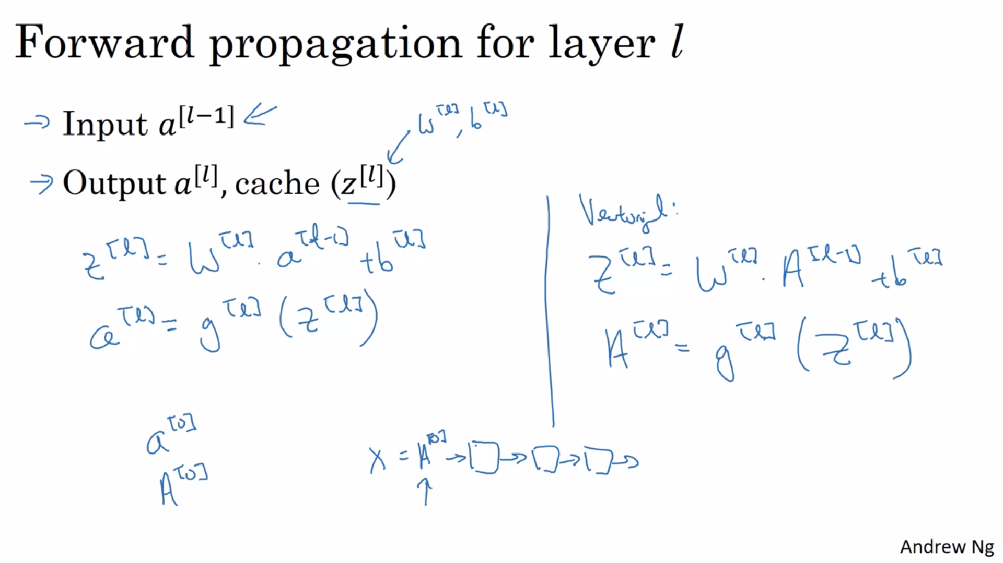

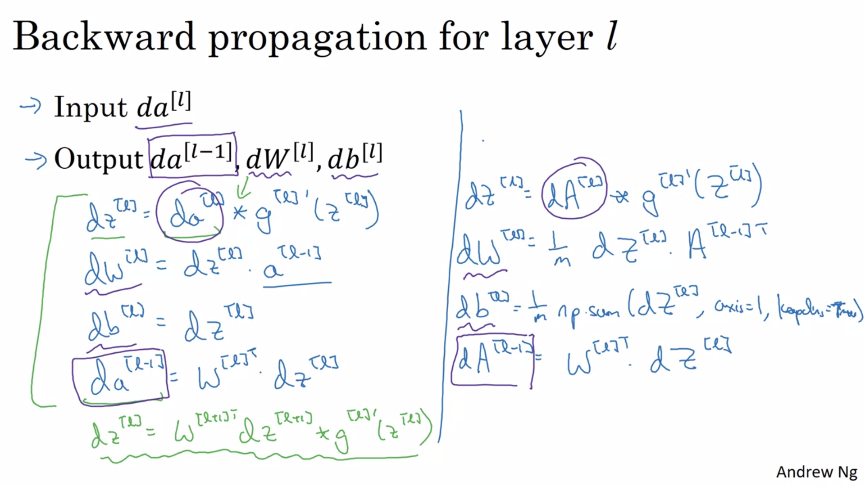

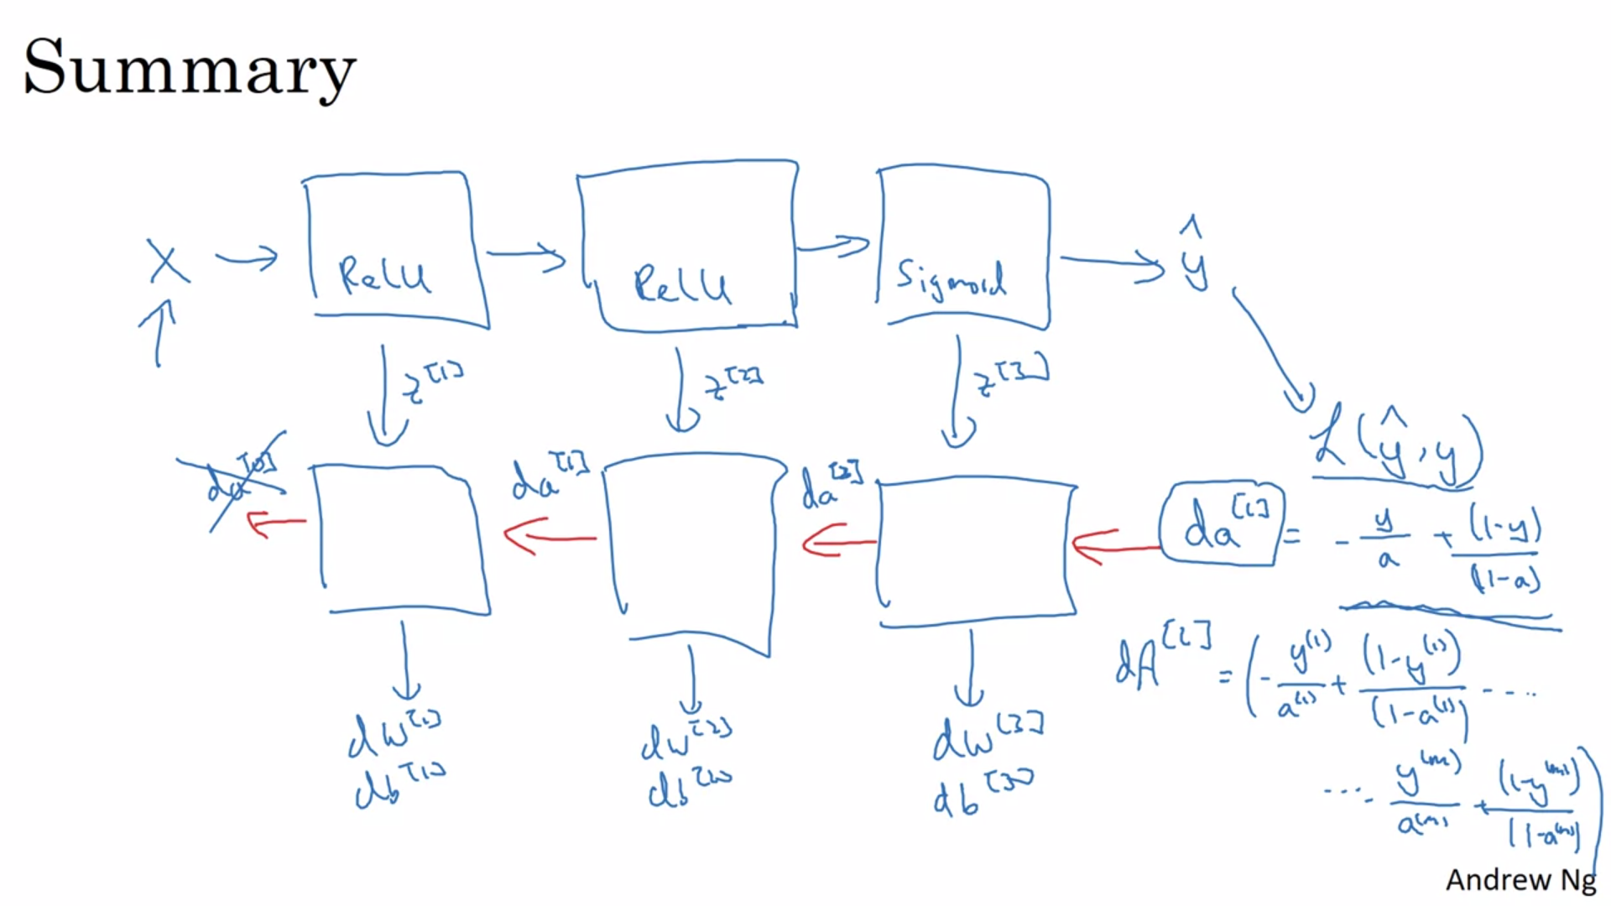

# Parameters vs Hyperparameters

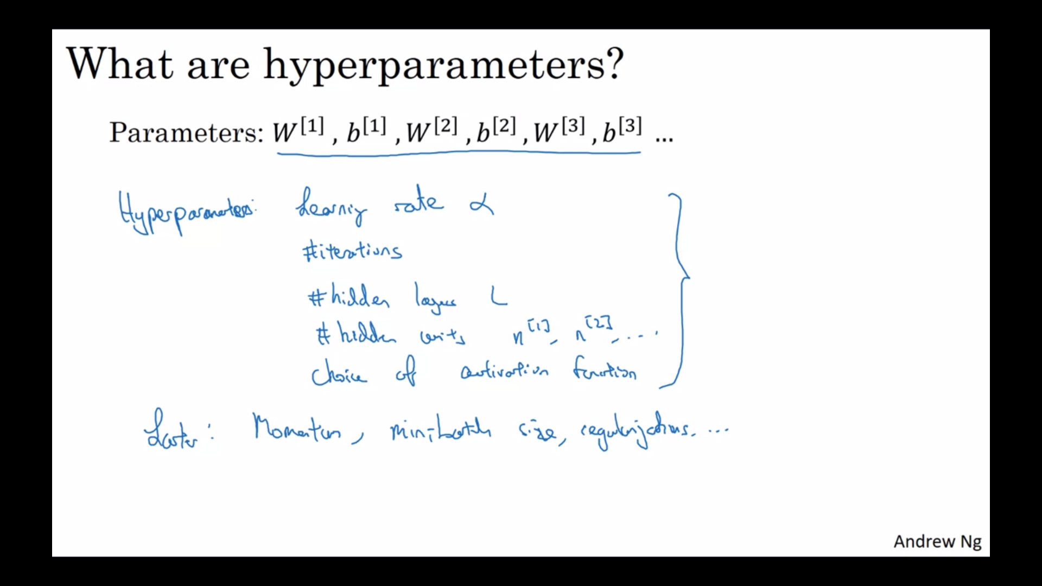

we call these things hyper parameters because it is the hyper parameters that you know somehow determine the final value of the parameters W and B

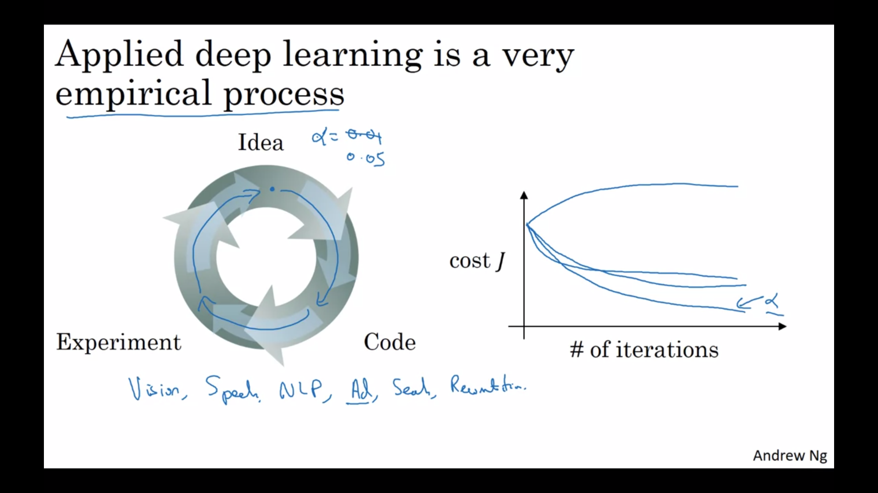

I often advise people

especially when starting on a new

problem to just try out a range of

values and see what works and then mix

course we'll see a systematic way we'll

see some systematic ways for trying out

a range of values all right and second

even if you're working on one

application for a long time you know

maybe you're working on online

advertising as you make progress on the

problem is quite possible there the best

value for the learning rate a number of

hidden units and so on might change so

even if you tune your system to the best

value of hyper parameters to daily as

possible you find that the best value

might change a year from now maybe

because the computer infrastructure I'd

be it you know CPUs or the type of GPU

running on or something has changed but

so maybe one rule of thumb is you know

every now and then maybe every few

months if you're working on a problem

for an extended period of time for many

years just try a few values for the

hyper parameters and double check if

there's a better value for the hyper

parameters and as you do so you slowly

gain intuition as well about the hyper

parameters that work best for your

problems

and I know that this might seem like an

unsatisfying part of deep learning that

you just have to try on all the values

for these hyper parameters but maybe

this is one area where deep learning

research is still advancing and maybe

over time we'll be able to give better

guidance for the best hyper parameters

to use but it's also possible that

because CPUs and GPUs and networks and

data says are all changing and it is

possible that the guidance won't to

converge for some time and you just need

to keep trying out different values and

evaluate them on a hold on

cross-validation set or something and

pick the value that works for your

problems

# What does this have to do with the brain?

Not much